1. Force system to check IMA box in “trucks” tab when NEU box is checked in “Orders” tab in combination with Duty paid

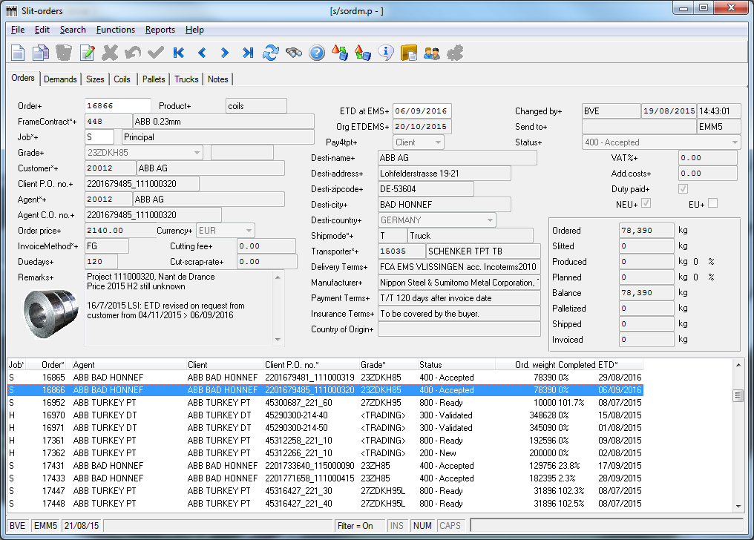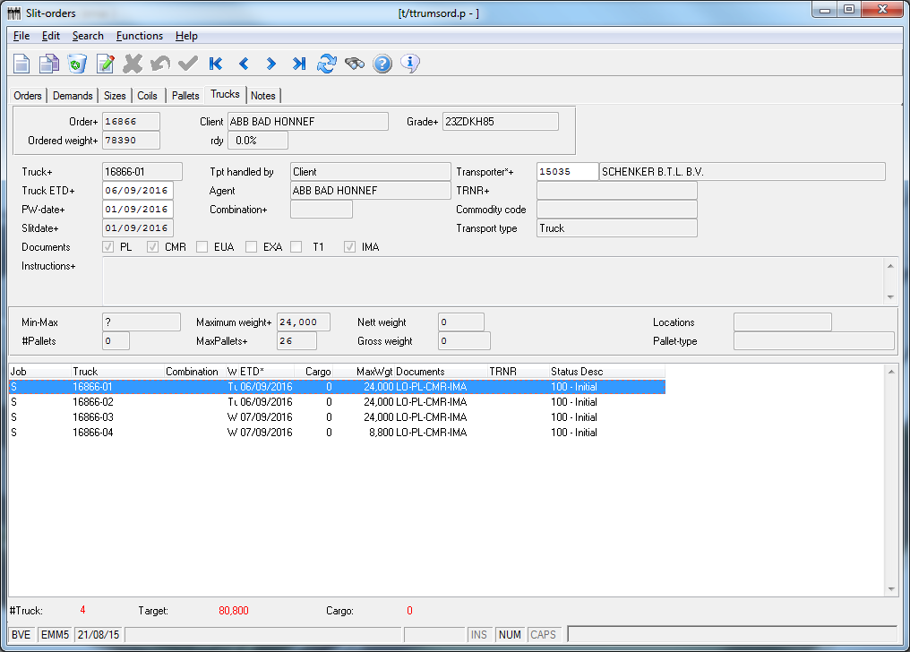

**In case Duty Paid box is NOT checked in combination with NEU, please force system to check T1 box. When EU box is checked there is no need to check T1 and/or IMA box.**